WEEK 3 – SELLER & INVENTORY MANAGEMENT SYSTEM
SQL Database Management Assignment

1. Create Tables
Seller
• Seller_ID
• Seller_Name
• Email
• Phone
• Address
Product
• Product_ID
• Product_Name
• Price
• Stock_Quantity
• Seller_ID
Inventory
• Inventory_ID
• Product_ID
• Seller_ID
• Stock_Quantity
• Stock_Status
• Last_Updated

2. Relationships & Constraints
• Seller → Product
• Product → Inventory
• Primary Key
• Foreign Key
• NOT NULL
• UNIQUE
• CHECK

3. SQL Code
CREATE DATABASE SellerInventoryDB;
USE SellerInventoryDB;
CREATE TABLE Seller (
Seller_ID INT PRIMARY KEY,
Seller_Name VARCHAR(100) NOT NULL,
Email VARCHAR(100) NOT NULL UNIQUE,
Phone VARCHAR(15) NOT NULL UNIQUE,
Address VARCHAR(200) NOT NULL
);

-- 2. PRODUCT TABLE

CREATE TABLE Product (
Product_ID INT PRIMARY KEY,
Product_Name VARCHAR(100) NOT NULL,
Price DECIMAL(10,2) NOT NULL CHECK (Price > 0),
Seller_ID INT NOT NULL,
FOREIGN KEY (Seller_ID) REFERENCES Seller(Seller_ID)
);
CREATE TABLE Inventory (
Inventory_ID INT PRIMARY KEY,
Product_ID INT NOT NULL UNIQUE,
Seller_ID INT NOT NULL,
Stock_Quantity INT NOT NULL CHECK (Stock_Quantity >= 0),
Stock_Status VARCHAR(20) NOT NULL
CHECK (Stock_Status IN ('Available','Low Stock','Out of Stock')),
Last_Updated DATE NOT NULL,
FOREIGN KEY (Product_ID) REFERENCES Product(Product_ID),
FOREIGN KEY (Seller_ID) REFERENCES Seller(Seller_ID)
);
INSERT INTO Seller VALUES
(1, 'Arun Traders', 'arun@gmail.com', '9876543210', 'Chennai'),
(2, 'Bala Stores', 'bala@gmail.com', '9876543211', 'Madurai'),
(3, 'Crown Suppliers', 'crown@gmail.com', '9876543212', 'Coimbatore'),
(4, 'Delta Mart', 'delta@gmail.com', '9876543213', 'Trichy'),
(5, 'Elite Distributors', 'elite@gmail.com', '9876543214', 'Salem');
INSERT INTO Product VALUES
(101, 'Laptop', 55000.00, 1),
(102, 'Keyboard', 1200.00, 1),
(103, 'Mouse', 700.00, 2),
(104, 'Monitor', 15000.00, 2),
(105, 'Printer', 12000.00, 3),
(106, 'Webcam', 2500.00, 3),
(107, 'Headset', 1800.00, 4),
(108, 'USB Drive', 900.00, 4),
(109, 'Router', 2200.00, 5),
(110, 'SSD', 6500.00, 5);
INSERT INTO Inventory VALUES
(1, 101, 1, 25, 'Available', '2026-09-20'),
(2, 102, 1, 8, 'Low Stock', '2026-09-20'),
(3, 103, 2, 15, 'Available', '2026-09-21'),
(4, 104, 2, 0, 'Out of Stock', '2026-09-21'),
(5, 105, 3, 12, 'Available', '2026-09-22'),
(6, 106, 3, 5, 'Low Stock', '2026-09-22'),
(7, 107, 4, 20, 'Available', '2026-09-23'),
(8, 108, 4, 0, 'Out of Stock', '2026-09-23'),
(9, 109, 5, 7, 'Low Stock', '2026-09-24'),
(10, 110, 5, 30, 'Available', '2026-09-24');
INSERT INTO Seller VALUES
(6, 'Future Suppliers', 'future@gmail.com', '9876543215', 'Tirunelveli');
INSERT INTO Product VALUES
(111, 'Tablet', 18000.00, 6);
SELECT s.Seller_Name, p.Product_ID, p.Product_Name
FROM Seller s
JOIN Product p
ON s.Seller_ID = p.Seller_ID;
SELECT s.Seller_ID, s.Seller_Name,
COUNT(p.Product_ID) AS Product_Count
FROM Seller s
LEFT JOIN Product p
ON s.Seller_ID = p.Seller_ID
GROUP BY s.Seller_ID, s.Seller_Name;
UPDATE Seller
SET Phone = '9876500000',
Address = 'Tirunelveli'
WHERE Seller_ID = 1;
SELECT p.Product_ID, p.Product_Name, i.Stock_Quantity
FROM Product p
JOIN Inventory i
ON p.Product_ID = i.Product_ID
WHERE i.Stock_Quantity > 0;
SELECT p.Product_ID, p.Product_Name
FROM Product p
JOIN Inventory i
ON p.Product_ID = i.Product_ID
WHERE i.Stock_Quantity = 0;
SELECT p.Product_ID, p.Product_Name,
i.Stock_Quantity
FROM Product p
JOIN Inventory i
ON p.Product_ID = i.Product_ID
WHERE i.Stock_Quantity < 10;

UPDATE Inventory
SET Stock_Quantity = 18,
Stock_Status = 'Available',
Last_Updated = '2026-09-25'
WHERE Product_ID = 102;

DELETE FROM Inventory
WHERE Product_ID = 108;

SELECT s.Seller_Name,
p.Product_Name,
i.Stock_Quantity,
i.Stock_Status
FROM Seller s
JOIN Product p
ON s.Seller_ID = p.Seller_ID
JOIN Inventory i
ON p.Product_ID = i.Product_ID
ORDER BY s.Seller_Name;

SELECT p.Product_Name,
i.Stock_Quantity,
i.Stock_Status
FROM Product p
JOIN Inventory i
ON p.Product_ID = i.Product_ID;

SELECT COUNT(*) AS Total_Available_Products
FROM Inventory
WHERE Stock_Quantity > 0;

SELECT COUNT(*) AS Total_Out_of_Stock_Products
FROM Inventory
WHERE Stock_Quantity = 0;

SELECT p.Product_Name,
i.Stock_Quantity
FROM Product p
JOIN Inventory i
ON p.Product_ID = i.Product_ID
WHERE i.Stock_Quantity =
(SELECT MAX(Stock_Quantity)
FROM Inventory);

SELECT AVG(Stock_Quantity) AS Average_Inventory_Quantity
FROM Inventory;

SELECT * FROM Seller;
SELECT * FROM Product;
SELECT * FROM Inventory;
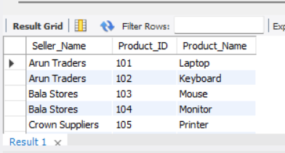
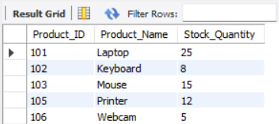
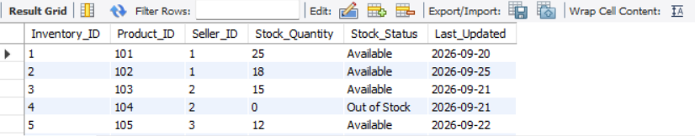

4. Operations Included
• Create Database
• Create Seller, Product and Inventory tables
• Insert sample records
• SELECT records
• JOIN Seller and Product
• JOIN Product and Inventory
• UPDATE inventory
• DELETE inventory record

5. Conclusion
The Seller and Inventory Management System stores seller, product and inventory details. Primary keys, foreign keys and constraints maintain data accuracy and relationships between tables.

